
Subject: Programming with Java
ASSIGNMENT No : 26
TITLE: Write a Java program to create and execute multiple threads using the Runnable interface..

Name: Avdhoot Mohite Class: CSE A2
PRN: 25070122056 Batch:25-29

Problem Statement
Write a Java program to create and execute multiple threads using the Runnable interface.
Learning Objectives
To create multiple threads using the Runnable interface.
Theory
The Runnable interface provides an alternative approach to creating threads in Java. A class implementing Runnable defines the run() method that contains the code executed by the thread. The Runnable object is passed to a Thread object, which starts execution using the start() method. Unlike extending the Thread class, implementing Runnable allows a class to inherit from another superclass, making the design more flexible. Runnable separates task definition from thread execution, resulting in better code organization and reusability. It is widely used in multithreaded enterprise applications and thread pool implementations.
Exercise
- Create a program using Runnable to run two tasks simultaneously.
CODE:
class Task1 implements Runnable {
public void run() {
for (int i = 1; i <= 5; i++) {
System.out.println("Task 1: " + i);

try {
Thread.sleep(500);
} catch (InterruptedException e) {
Thread.currentThread().interrupt();
return;
}
}
}
}

class Task2 implements Runnable {
public void run() {
for (int i = 1; i <= 5; i++) {
System.out.println("Task 2: " + i);

try {
Thread.sleep(500);
} catch (InterruptedException e) {
Thread.currentThread().interrupt();
return;
}
}
}
}

public class assignment26a {
public static void main(String[] args) {

Thread t1 = new Thread(new Task1());
Thread t2 = new Thread(new Task2());

System.out.println("Starting both tasks...");

t1.start();
t2.start();

try {
t1.join();
t2.join();
} catch (InterruptedException e) {
Thread.currentThread().interrupt();
return;
}

System.out.println("Both tasks completed.");
}
}

OUTPUT:
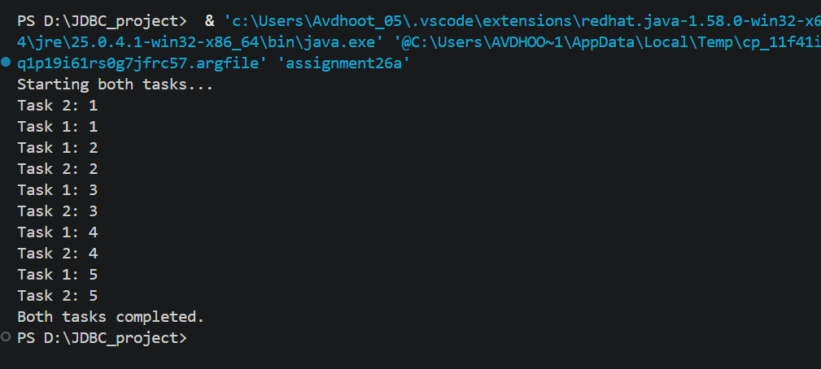
- Create a Java program using the Runnable interface where two tasks run simultaneously: one thread performs deposit operations, and another performs withdrawal operations, both displaying results concurrently.
CODE:

class BankAccount26 {
private int balance = 5000;

synchronized void deposit(int amount) {
balance += amount;
System.out.println("Deposited: Rs. " + amount);
System.out.println("Balance: Rs. " + balance);
}

synchronized void withdraw(int amount) {
if (balance >= amount) {
balance -= amount;
System.out.println("Withdrawn: Rs. " + amount);
System.out.println("Balance: Rs. " + balance);
} else {
System.out.println("Insufficient Balance!");
}
}

synchronized int getBalance() {
return balance;
}
}

class DepositTask26 implements Runnable {
private final BankAccount26 account;

DepositTask26(BankAccount26 account) {
this.account = account;
}

public void run() {
for (int i = 1; i <= 3; i++) {
account.deposit(1000);

try {
Thread.sleep(500);
} catch (InterruptedException e) {
Thread.currentThread().interrupt();
return;
}
}
}
}

class WithdrawTask26 implements Runnable {
private final BankAccount26 account;

WithdrawTask26(BankAccount26 account) {
this.account = account;
}

public void run() {
for (int i = 1; i <= 3; i++) {
account.withdraw(500);

try {
Thread.sleep(500);
} catch (InterruptedException e) {
Thread.currentThread().interrupt();
return;
}
}
}
}

public class assignment26b {
public static void main(String[] args) {

BankAccount26 account = new BankAccount26();

Thread t1 = new Thread(new DepositTask26(account));
Thread t2 = new Thread(new WithdrawTask26(account));

System.out.println("Initial Balance: Rs. 5000");

t1.start();
t2.start();

try {
t1.join();
t2.join();
} catch (InterruptedException e) {
Thread.currentThread().interrupt();
return;
}

System.out.println("Final Balance: Rs. " + account.getBalance());
}
}

OUTPUT:
